Case 6**-Afr-Gabon, Punu *Mukudj* Mask on a Reliquary Door, 19th c**

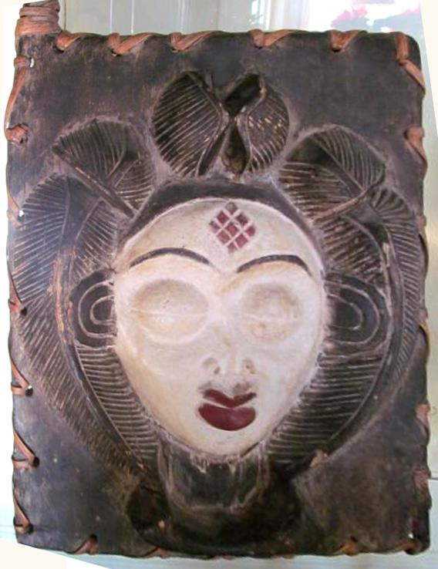

**Gabon, Punu *Mukudj* Mask on a Reliquary Door, 19th century, wood, pigments, kaolin.**

Formal Label: **Gabon, Punu *Mukudj* Mask on a Reliquary Door, 19th century**

Accession Number:

LC Classification: GT1748

Date or Time Horizon: 19th century

Geographical Area:

Cultural Affiliation:

Medium: wood, pigments, kaolin

Dimensions: Weight:

Provenance:

**Condition:**

**Discussion:** The Punu of southern Gabon's upper Ngoumie River live in independent villages. These villages had male wood sculptors who immortalized the most revered women of the village by carving a *Mukudj* mask like the one that is carved on this door of a reliquary. The reliquary probably contained a statuette of the woman whose face is carved on the door itself. The surface of her idealized portrait is painted with kaolin which represents the ethereal spirit of this ancestress. The beautiful hairstyle she wears is a common feature among the Punu women, as is scarification on the forehead, a pointed nose, protruding lips, arched eyebrows narrow eyes and closed mouth. Masks such as this are used by chiefs to consult with the ancestors to divine solutions to communal problems. While numerous examples of masks of female figures comissioned by diviners are represented in western collections, this present work is the only known example of an authentic reliquary door known to survive.

*Mukudj* masks are now used to entertain audiences during festivals or celebrations. On rare occasions *Mukudj* masks are used during divinations. During these rituals masqueraders dance and they embody the spirits of male and female ancestors in hopes of eliciting the proper action by which to proceed in resolving a communal issue.

**References:**

Perrois, Louis and Charlotte Grand-Dufay. 2008. *Punu*. Tr. Isabel Ollivier. Milan: 5 Continents.